The Rabbits
The Rabbits, written by John Marsden, is partly allegorical fable about colonisation, told from the viewpoint of the colonised. An unseen narrator describes the coming of ‘rabbits’ in the most minimal detail, an encounter that is at first friendly and curious, but later darkens as it becomes apparent that the visitors are actually invaders. The style of the book is deliberately sparse and strange, with both text and image conveying an overall sense of bewilderment and anxiety as native numbat-like creatures witness environmental devastation under the wheels of a strange new culture.
> Click here for further comment about The Rabbits.
> Click here for a interview about The Rabbits from 1998.
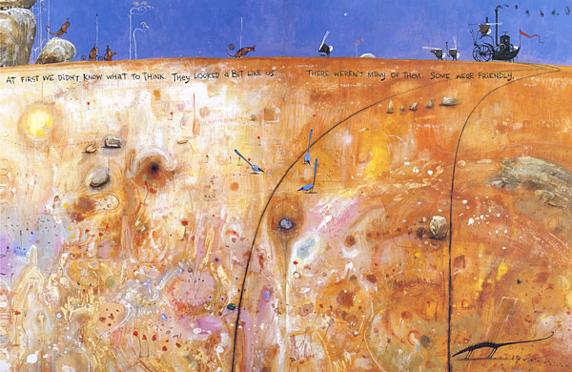

‘The meeting on the hill’ acrylic, gouache, ink and coloured pencil.
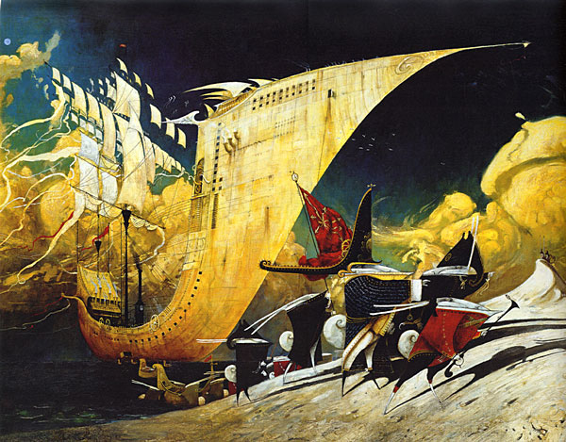

‘They came by water’ Oil on canvas.
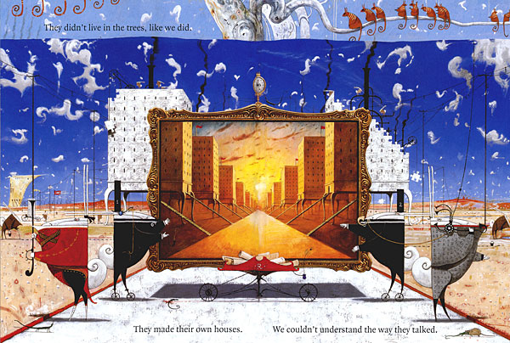

‘The building of the houses’ acrylic, gouache and coloured pencil.
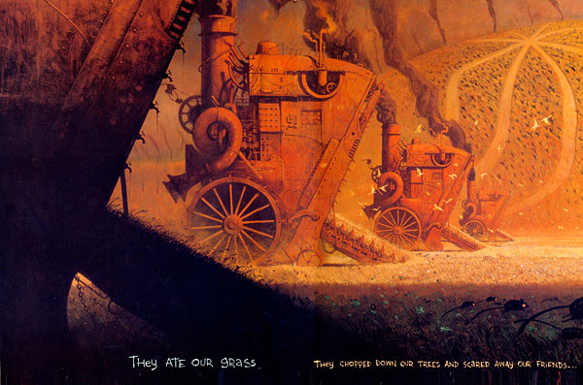

‘They ate our grass’ gouache and coloured pencil.

Comments on The Rabbits
The parallels with a real history of colonisation in Australia and around the world are obvious, and based on detailed research, in spite of the overt surrealism of the imagery and the absence of direct references. It was named Picture Book of the Year by the Children’s Book Council, which in part generated some controversy due to it’s confronting themes, and was attacked on several occasions for being ‘politically correct propaganda’, but only by right wing conservatives of course. In spite of this (or because of it), the book went on to win numerous awards in Australia, the US and UK, and is studied widely in secondary schools. It would seem that some of my concepts and designs were unacknowledged inspiration for a section of the opening ceremony of the 2000 Sydney Olympics, although I’ve never been able to find out if this is true.
One reason for the initial controversy is that The Rabbits is a picture book, and therefore thought to be children’s literature, and wrongly assumed to be didactic, whereas it had been originally conceived as a book for older readers, and generally difficult to categorise. Some children may get a lot out of it, but generally it defies most picture book conventions and is not necessarily a good choice for pleasant bedtime reading!

